**Project Design Phase**

**Solution Architecture**

|  |  |
| --- | --- |
| Date | 28 june 2025 |
| Team ID | LTVIP2025TMID35624 |
| Project Name | Revolutionizing Liver Care: Predicting Liver Cirrhosis Using Advanced Machine Learning Techniques |
| Maximum Marks | 4 Marks |

**Solution Architecture:**

This solution architecture outlines the design of a machine learning-powered web application for early prediction of liver cirrhosis using non-invasive clinical and laboratory data. The system enables patients or healthcare providers to input relevant medical information through an intuitive frontend interface, which communicates with a Flask-based backend API for real-time prediction.

The backend leverages a trained Random Forest model integrated with a preprocessing pipeline to ensure consistent and accurate classification. Results are returned instantly to the user, allowing for timely medical insights.

In addition to prediction, the system includes a secure contact form that lets users reach out to administrators or support staff. Email integration enables structured communication, and all model artifacts are efficiently serialized and loaded on demand for scalability.

**Solution Architecture Diagram:**

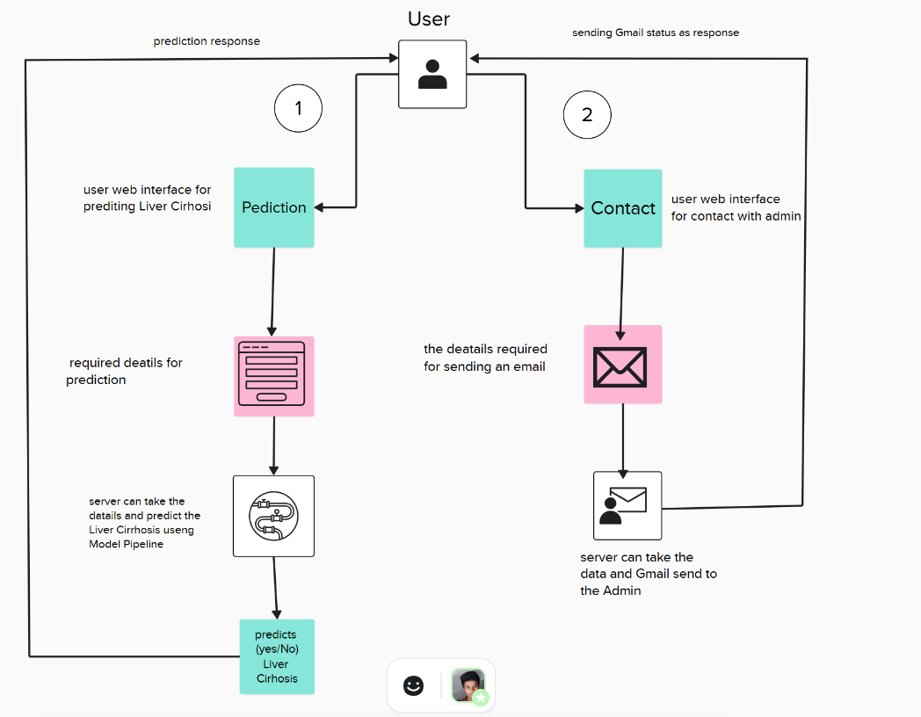

*Figure 1: Architecture and data flow of the Predicting Liver Cirrhosis application*

**Data Flow Architecture**

The system processes medical data through a structured pipeline from user input to prediction output.

Medical Data Processing Pipeline